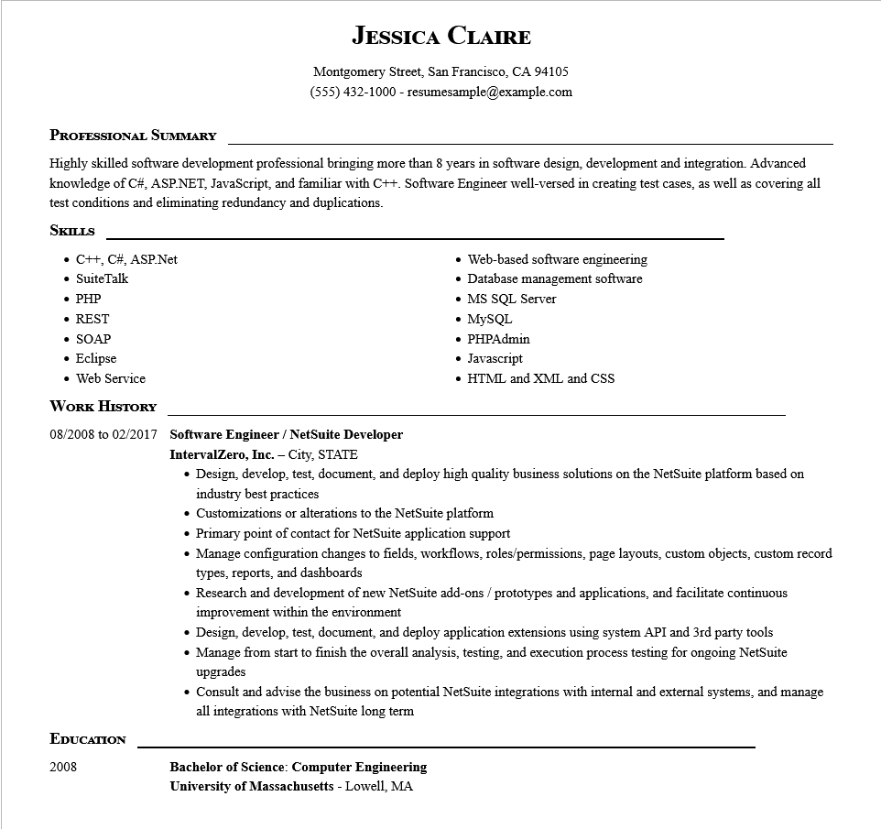
JESSICA CLAIRE
Montgomery Street, San Francisco, CA 94105
(555) 432-1000-resumesample@example.com
PROFESSIONAL SUMMARY
Highly skilled software development professional bringing more than 8 years in software design, development and integration. Advanced knowledge of C#, ASP.NET, JavaScript, and familiar with C++. Software Engineer well-versed in creating test cases, as well as covering all test conditions and eliminating redundancy and duplications.
SKILLS
• C++, C#, ASP.Net
Suite Talk
• PHP
• REST
• SOAP
• Eclipse
• Web-based software engineering
• Database management software
• MS SQL Server
• MySQL
⚫ PHPAdmin
• Javascript
• Web Service
WORK HISTORY
08/2008 to 02/2017
Software Engineer / NetSuite Developer
. HTML and XML and CSS
EDUCATION
2008
IntervalZero, Inc. - City, STATE
• Design, develop, test, document, and deploy high quality business solutions on the NetSuite platform based on industry best practices
• Customizations or alterations to the NetSuite platform
• Primary point of contact for NetSuite application support
• Manage configuration changes to fields, workflows, roles/permissions, page layouts, custom objects, custom record types, reports, and dashboards
• Research and development of new NetSuite add-ons / prototypes and applications, and facilitate continuous improvement within the environment
• Design, develop, test, document, and deploy application extensions using system API and 3rd party tools Manage from start to finish the overall analysis, testing, and execution process testing for ongoing NetSuite upgrades
• Consult and advise the business on potential NetSuite integrations with internal and external systems, and manage all integrations with NetSuite long term
Bachelor of Science: Computer Engineering University of Massachusetts - Lowell, MA

